Wright State University

Modernizing the Electric Grid

A Step Towards a Greener and More Reliable Future

Alex Yeoh

ENG 2140

Professor Tracy E. Smith

28 July 2022

**Table of Contents**

Cover Page – Modernizing the Electric Grid 1

Table of Contents 2

Table of Figures 2

Introduction 3

Problem 3  
Proposed Solution 6  
Defense of Solution 8  
Conclusion 9  
Works Cited 10

**Table of Figures**

*Figure 1*:2020 United States and Puerto Rico census map 4

*Figure 2*: Total estimated potential onshore wind power in the United States 4  
*Figure 3*: Average duration of total annual electric power interruptions (2013 - 2020) 5

*Figure 4*: 1980-2021 United States billion-dollar disaster event cost (CPI-Adjusted) 5

*Figure 5*: Total estimated potential urban utility-scale photovoltaics in the United States 7

*Figure 6*: Cumulative U.S. Solar Installations 9

**Introduction**

In light of recent news, the Texas power grid is incapable of functioning reliably during neither winter nor summer (McWilliams; Wood). This is only one example of a widespread issue in the United States; however, it does not have to be this way. The electrical grid was built over a century ago, before the idea of global warming and its potential impacts existed. This unfortunate truth about the electrical grid has led to its lack of capacity and reliability in the modern age. However, it is not all doom and gloom, this issue can be fixed by modernizing the electrical grid. The electrical grid can have its capacity increased through the installation of new high voltage DC transmission lines and its reliability can be improved with the implementation of microgrids.

**Problem**

The electrical grid has served its purpose remarkably for over a century, but it is now in a dire need for modernization. For it to best service the needs of the modern age, the main issues that need to be resolved are its lack of capacity and reliability.

The lack of capacity will be a major issue as the United States continues its transition to being powered by renewable energy sources. This issue has already begun to pop up as John Dillon, a senior reporter at Vermont Public Radio, reported on a situation where a new solar instillation was halted due to the electric grid not having the capacity to handle the new power output that the instillation would have generated (Dillion). This problem is bound to crop up again and again as the United States will inevitably need to transfer power generated from regions with a low population density, and subsequently a relatively low electricity demand, but high renewable energy generation potential (as seen in *figure 1* and *figure 2*) to regions with a high population density (as seen in *figure 1*).

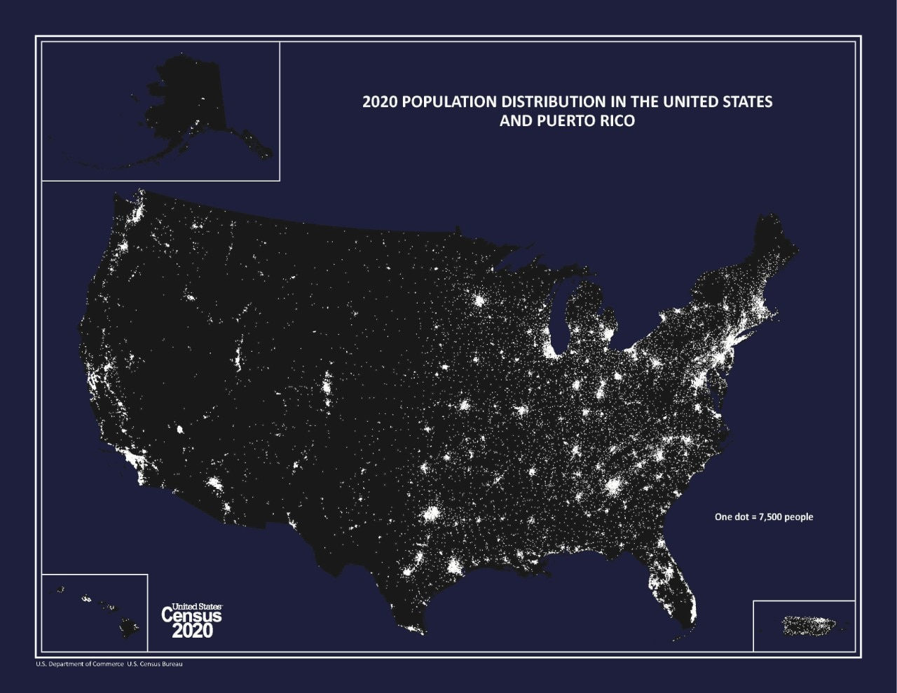

*Figure 1*:2020 United States and Puerto Rico census map   
(Source: “2020 Population Distribution in the United States and Puerto Rico”)

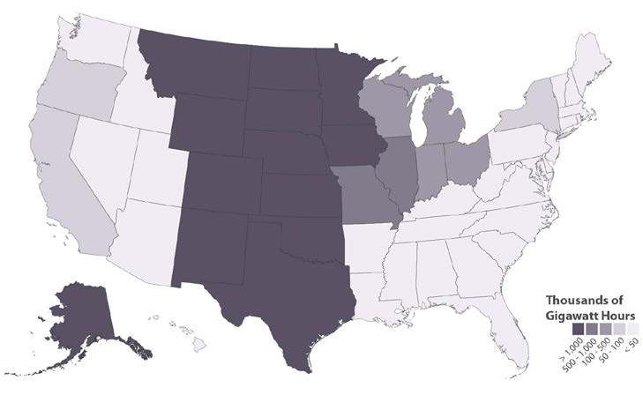

*Figure 2*: Total estimated potential onshore wind power in the United States  
(Source: Lopez, Anthony, et al. 14)

A lack of capacity is not the only pressing issue that the electrical grid must improve upon; it must also improve its overall reliability. The overall lack of reliability can be seen in Associated Press’ analysis of government data where they concluded there was a greater than doubling of power outages related to severe weather when comparing data from the early 2000s and the past five years, and increased frequency and length of power failures since recording started, among other data points (Brown, Matthew, et al.). Without improving reliability, blackouts and rolling blackouts like the potential Texas rolling blackout that Gary McWilliams, a reporter for Reuters who works with a team of energy reporters, reported on are bound to become more frequent (McWilliams). This inevitability can be better seen when comparing figure *3* to *figure 4* and noting the increase in average power interruptions due to major events from *figure 3* and the increased rate of billion-dollar disaster events from *figure 4* which would almost certainly be major events.

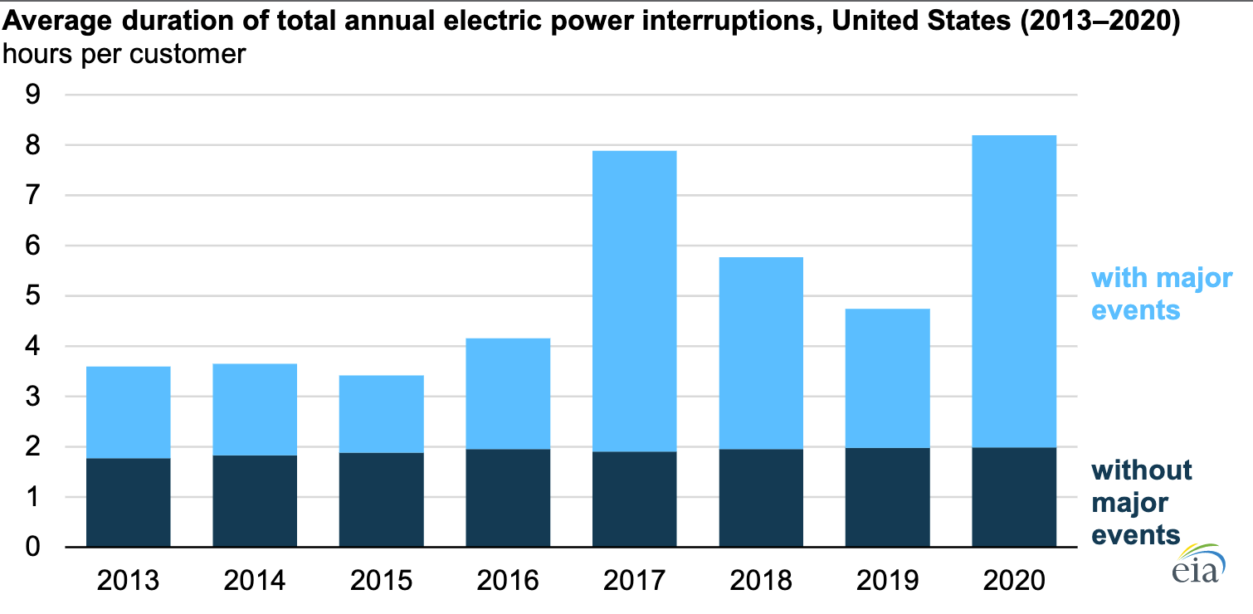

*Figure 3*: Average duration of total annual electric power interruptions (2013 - 2020)  
(Source: Lindstrom & Hoff)

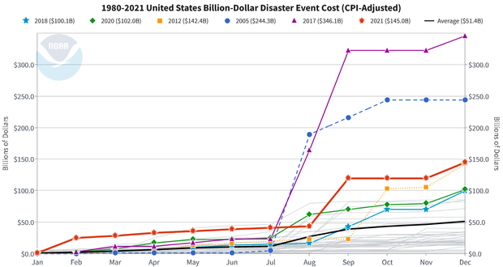

*Figure 4*: 1980-2021 United States billion-dollar disaster event cost (CPI-Adjusted)  
(Source: Smith)

**Proposed Solution**

The issues with the current electrical grid may be complex and numerous, but for the specific issues of capacity and reliability, there is an intuitive solution available. Instillation of new high voltage DC transmission lines will be required for solving the capacity issue with an additional side effect of also helping alleviate the reliability issue. To fully alleviate the reliability issue in all but the most serious cases, implementation of microgrids will be necessary.

To increase capacity, instillation of new high voltage DC transmission lines will be necessary. To best solve the specific issue of increasing capacity to utilize abundant renewable energy sources from low demand regions, the new transmission lines will have to transfer power between regions like the Pacific Northwest/Pacific Southwest Intertie does (“Pacific Intertie” 2). The instillation of new transmission lines will not only be able to help increase capacity, but it will also be able to help with the issues with reliability. With the implementation of cross-region transmission lines, should there be an issue with power generation in the low density regions that would ordinarily be exporting electricity to higher demand regions, power could be routed in the other direction from states such as the darkly shaded ones in *figure 5* back to the region that now needs power in a manner not dissimilar to the Pacific Northwest/Pacific Southwest Intertie does (“Pacific Intertie” 2).

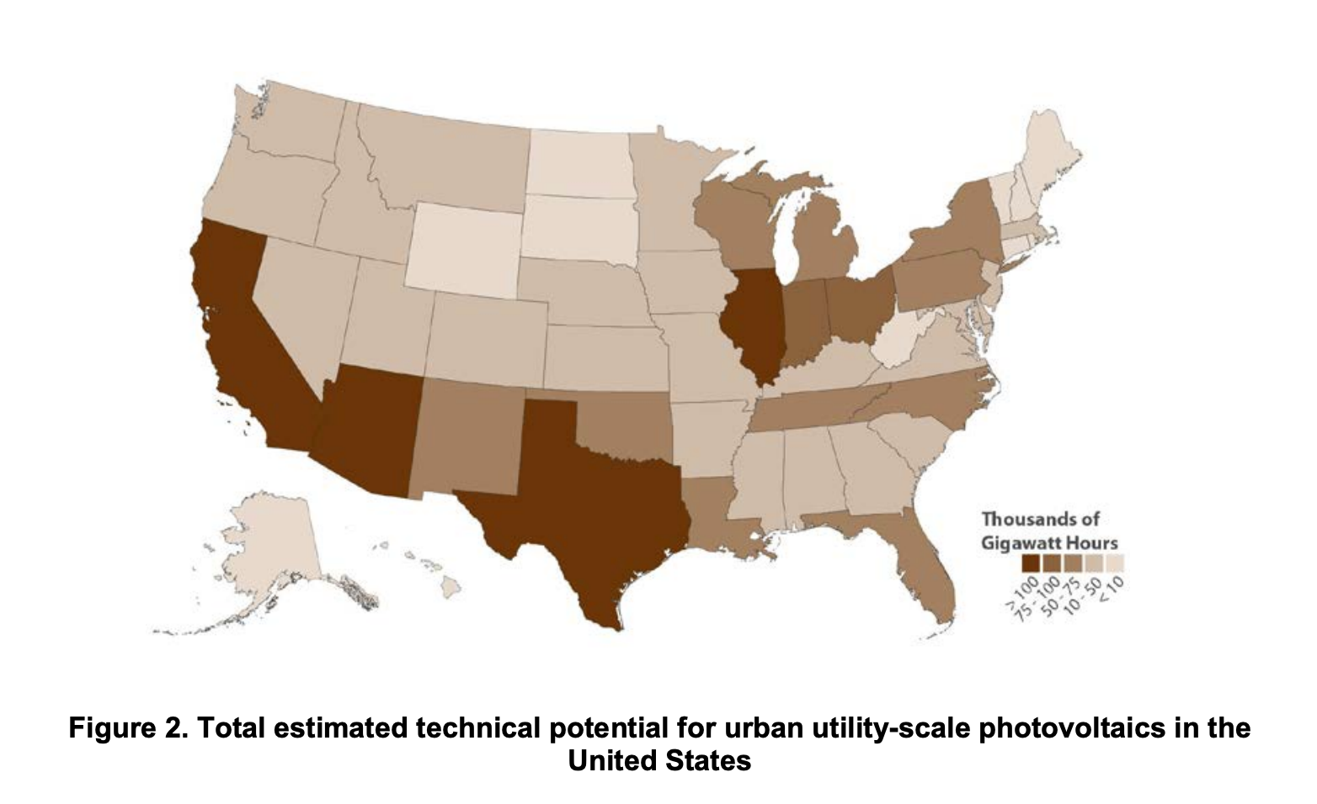

*Figure 5*: Total estimated potential urban utility-scale photovoltaics in the United States

(Source: Lopez, Anthony, et al. 10)

To further improve reliability of the electric grid, microgrids should be implemented. Implementing microgrids can help improve reliability due to their ability to easily disconnect from the larger grid, should there be an issue with it, and sustain itself with local power generation for until the issue that necessitated the disconnection is resolved (Prabakar). This technology has already proved its usefulness in exactly this sort of situation during the 2021 Texas power crisis, where when the state’s electrical grid operator called for controlled blackouts for noncritical customers, microgrids were able to keep their lights on due to their ability to subsist without the grid providing electricity for prolonged periods of time (Wood).

The instillation of new high voltage DC transmission lines would not only set the stage for a future where available renewable energy sources would be ripe for exploitation, but also improve the reliability of the grid by allowing different regions to better support each other during their times of need. The implementation of microgrids would allow for even greater reliability in a more local area allowing neighbors to support each other in their collective time of need. Through the instillation of new transmission lines and implementation of microgrids, any issues regarding capacity and reliability will be resolved for the foreseeable future.

**Defense of Solution**

Regarding capacity, there is no other known way to reasonably increase the electric grids capacity. However, there is a way to functionally increase grid capacity; as mentioned by Aaron Larson, an executive editor at *POWER* magazine who has years of experience working on various power stations, it is possible to functionally increase grid capacity by optimizing what already exists, but that would only be a stop gap for the inevitably need for more transmission lines (Larson).

Even with the knowledge that this can work, opponents may question if the costs necessary for such a large infrastructure project would be excessive; however, an article by Molly Seltzer, who was a communications specialist for the Andlinger Center for Energy & the Environment at Princeton University during the time they wrote the article, discussing the results of an in depth analysis about various paths to a net-zero America by 2050 resulted in every pathway achieving that goal within historic annual spending on energy (Seltzer). This research is pertinent to this discussion of cost due to the research having also accounted for the need to install new transmission lines; with the cost of transmission lines already accounted in a goal far above simply installing new transmission lines still falling within historic annual spending on energy, would render all doubts about excessive costs for this project moot (Seltzer).

With questions about transmission lines put to rest, opponents may move onto question how implementable would microgrids be. However, this question too, is easy to render moot by simply observing *figure 6* which shows the rapid growth of residential and commercial solar. However, current residential and commercial solar are only a single facet of microgrids, as they may consist of other power sources and other technologies depending on how and which entities implement them.

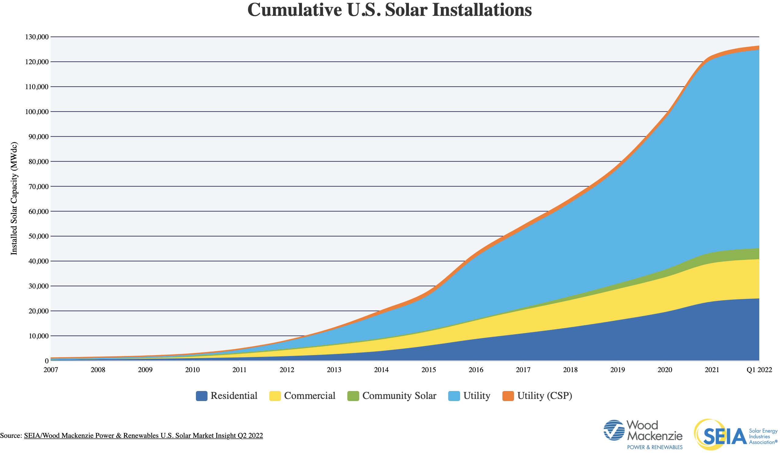

*Figure 6*: Cumulative U.S. Solar Installations

(Source: “Solar Industry Research Data”)

**Conclusion**

Without implementing these solutions, the utilization of available renewable power sources will be greatly limited, and quality of life will continue to diminish as the reliability of the power grid continues to faulter. With the implementation of these solutions, a step towards a greener future would have been taken and along with that, the wellbeing of the citizenry will also be better secured from all but the most extreme situations. All those benefits just with the instillation of new high voltage DC transmission lines that will increase capacity and reliability along with the implementation of microgrids that will further secure the reliability of the electric grid.

Works Cited

“2020 Population Distribution in the United States and Puerto Rico.” *United States Census Bureau*, 19 Oct. 2021, https://www.census.gov/library/visualizations/2021/geo/population-distribution-2020.html.

Brown, Matthew, et al. “Storms Batter Aging Power Grid as Climate Disasters Spread.” *AP NEWS*, Associated Press, 6 Apr. 2022, https://apnews.com/article/wildfires-storms-science-business-health-7a0fb8c998c1d56759989dda62292379.

Dillon, John. “Transmission Grid Bottlenecks in Northeast Kingdom Stall Solar Development.” *Vermont Public*, 17 Dec. 2020, https://www.vermontpublic.org/vpr-news/2020-12-15/transmission-grid-bottlenecks-in-northeast-kingdom-stall-solar-development.

Larson, Aaron. “How to Get up to 40% More Capacity from Existing Power Grid Transmission Lines.” *POWER Magazine*, 4 Nov. 2021, https://www.powermag.com/how-to-get-up-to-40-more-capacity-from-existing-power-grid-transmission-lines/.

Lindstrom, Anodyne, and Sara Hoff. “U.S. Electricity Customers Experienced Eight Hours of Power Interruptions in 2020.” *Homepage - U.S. Energy Information Administration (EIA)*, 10 Nov. 2021, https://www.eia.gov/todayinenergy/detail.php?id=50316.

Lopez, Anthony, et al. “U.S. Renewable Energy Technical Potentials: A GIS-Based Analysis - NREL.” *National Renewable Energy Laboratory*, July 2012, https://www.nrel.gov/docs/fy12osti/51946.pdf.

McWilliams, Gary. “Texas Grid Operator Warns of Potential Rolling Blackouts on Monday.” *Reuters*, Thomson Reuters, 11 July 2022, https://www.reuters.com/world/us/texas-grid-operator-warns-potential-rolling-blackouts-monday-2022-07-11/.

“Pacific Intertie: The California Connection on the Electron Superhighway.” *Pacific Intertie: The California Connection on the Electron Superhighway*, 1 May 2001, https://www.nwcouncil.org/reports/pacific-intertie-california-connection-electron-superhighway/.

Prabakar, Kumaraguru. “Microgrids.” *NREL.gov*, https://www.nrel.gov/grid/microgrids.html.

Seltzer, Molly, and Andlinger Center for Energy and the Environment. “Big but Affordable Effort Needed for America to Reach Net-Zero Emissions by 2050, Princeton Study Shows.” *Princeton University*, The Trustees of Princeton University, 15 Dec. 2020, https://www.princeton.edu/news/2020/12/15/big-affordable-effort-needed-america-reach-net-zero-emissions-2050-princeton-study.

Smith, Adam B. “2021 U.S. Billion-Dollar Weather and Climate Disasters in Historical Context.” *2021 U.S. Billion-Dollar Weather and Climate Disasters in Historical Context | NOAA Climate.gov*, 24 Jan. 2022, https://www.climate.gov/news-features/blogs/beyond-data/2021-us-billion-dollar-weather-and-climate-disasters-historical.

“Solar Industry Research Data.” *Solar Energy Industries Association*, https://www.seia.org/solar-industry-research-data.

Wood, Elisa. “Microgrids Help Texas as It's Forced to Undertake Rolling Blackouts.” *Microgrid Knowledge*, 28 Aug. 2021, https://microgridknowledge.com/microgrids-texas-blackouts/.